Car service Drives from location to location

Water and drinks included

Photo booth set up with rothco backdrop and spy props

Friends dressed as spies - hoodies to suits.

The gift will be there waiting.

Photo booth props
Backdrop is a brightly lit shower curtain printed with a Rothko painting.
[ ] sunglasses
[ ] hoodie
[ ] raincoat
[ ] binoculars
[ ] Briefcase (with bullet holes)
[ ] walkie talkie
[ ] secret service ear bud
[ ] passports
[ ] Currencies
[ ] mugshot cards?
[ ] raincoats
[ ] fedoras
[ ] Dossier in manila envelope — with Rosey’s details.
[ ] prop guns
[ ] magnifying glass
[ ] Clapboard with “Without Monsters and Gods, art cannot enact a drama.”
— Photo, name, address, place of work, birthdate, log of missions, marked confidential
-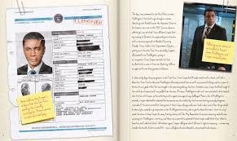

Can we add crosshairs to the photo booth?

